**IMPACT OF GAMIFICATION IN EDUCATION: STATISTICAL ANALYSIS**

**Tanisha Fairooz**

**Introduction:** In the field of education, gamification refers to the process of incorporating game mechanics and concepts into educational settings in order to achieve an increase in the level of enthusiasm and involvement in the learning process. Because of its adaptable and flexible framework, gamification has the potential to be utilized in a wide variety of contexts, including fields of study, age groups, learning methods, and individual preferences.

**Objectives:**

* + To analyze the impact of gamification on student engagement.
  + To evaluate the effectiveness of gamification on learning outcomes.
  + To identify key game elements that enhance the learning experience.

**Methods:**

Data origin: Primary data using google forms

Analysis tool: IBM SPSS, MS Excel

**Procedure of analysis using SPSS**

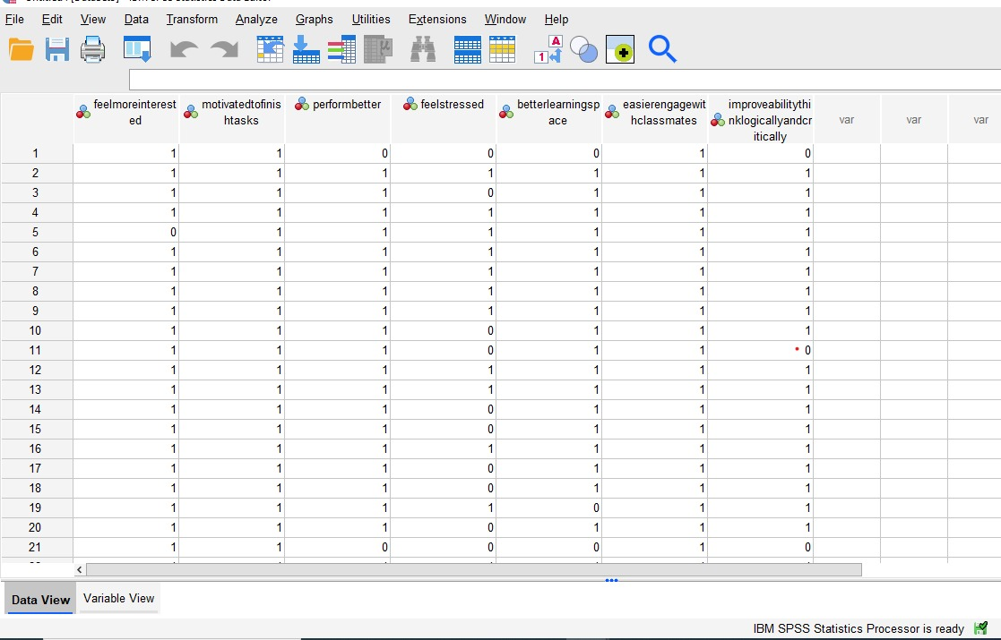













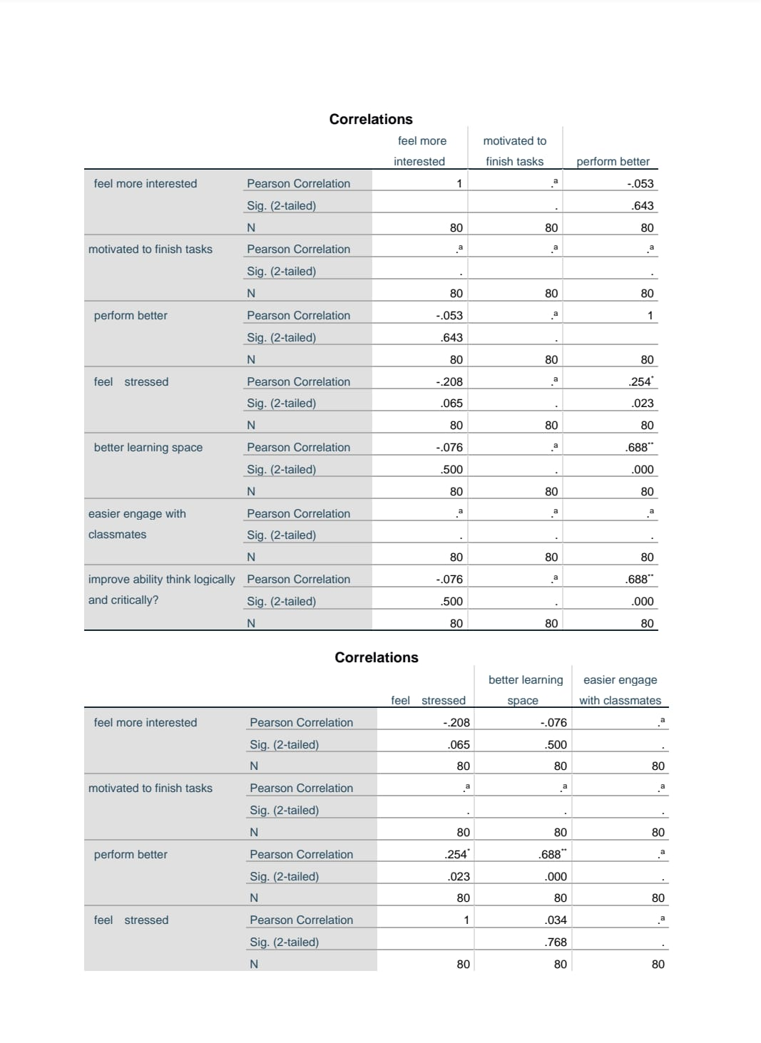

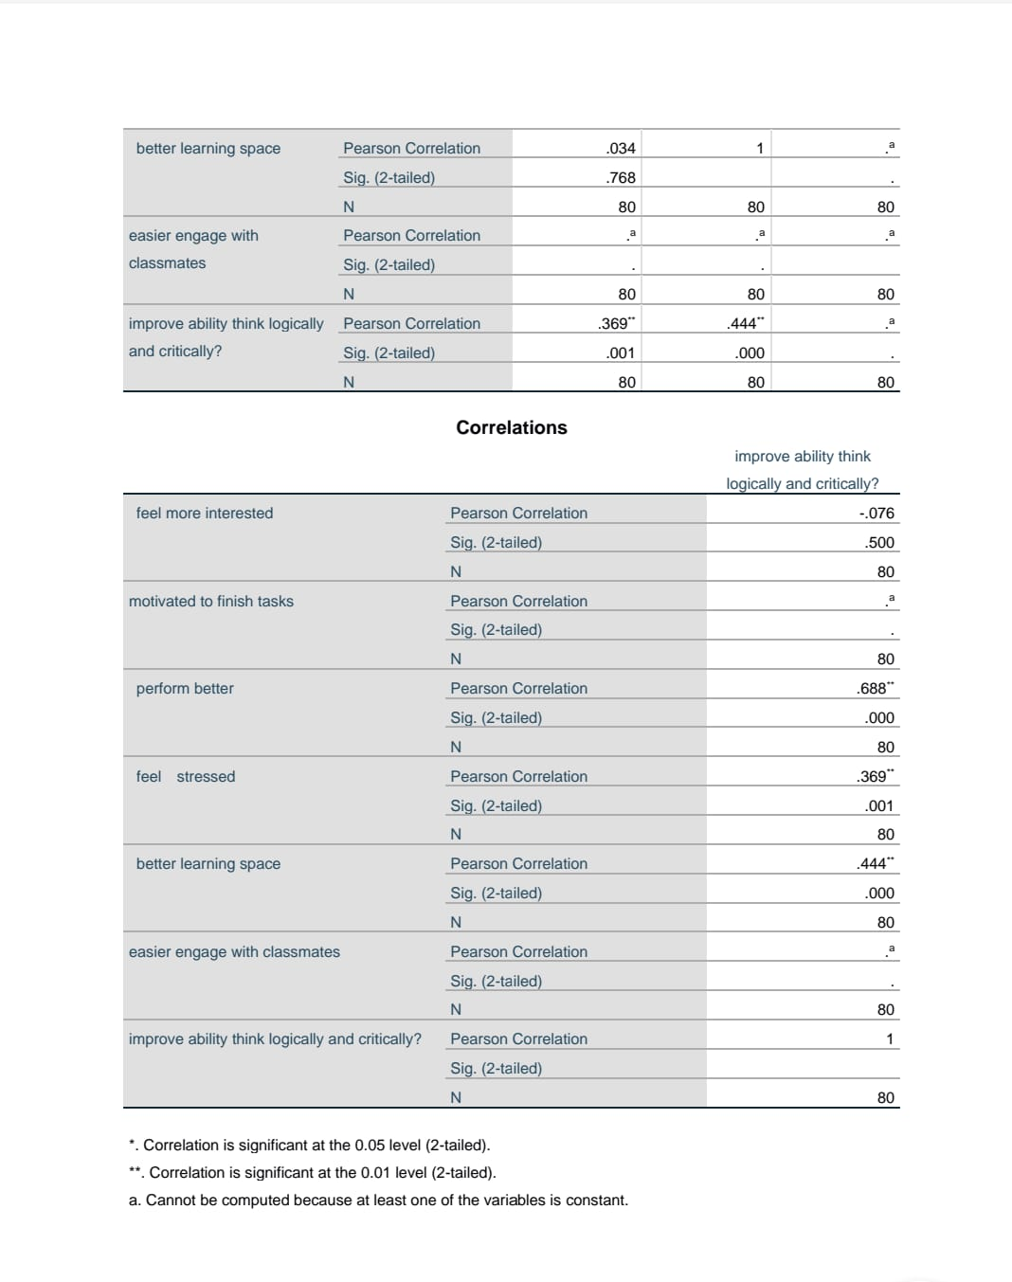

**Results:**

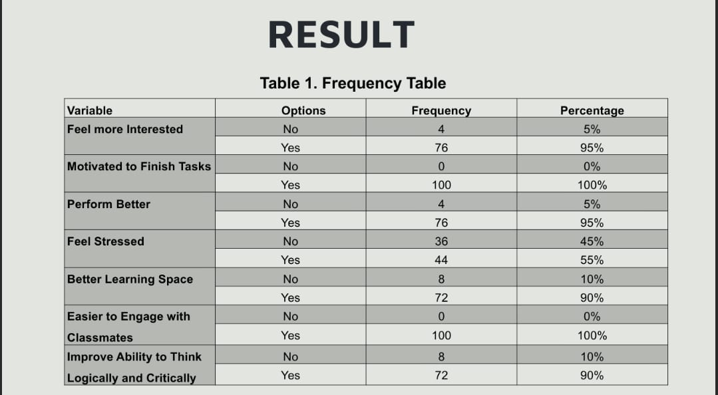

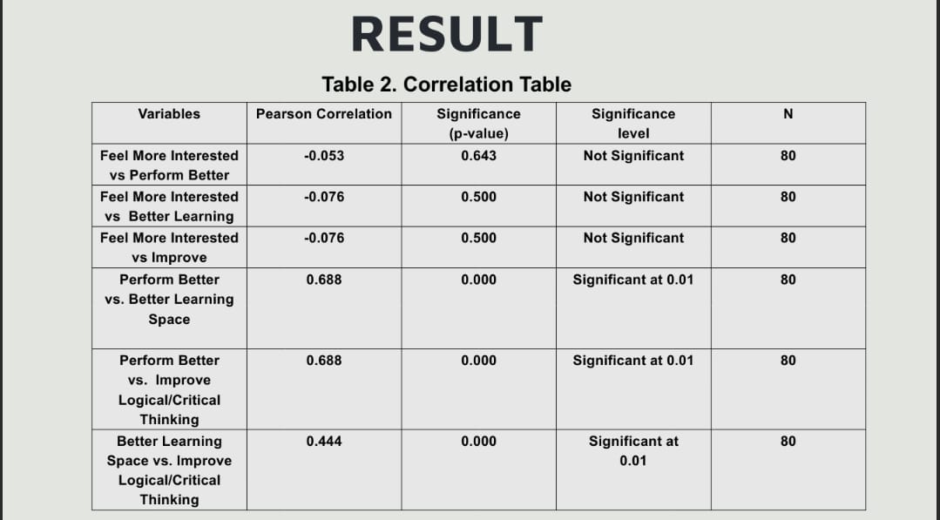

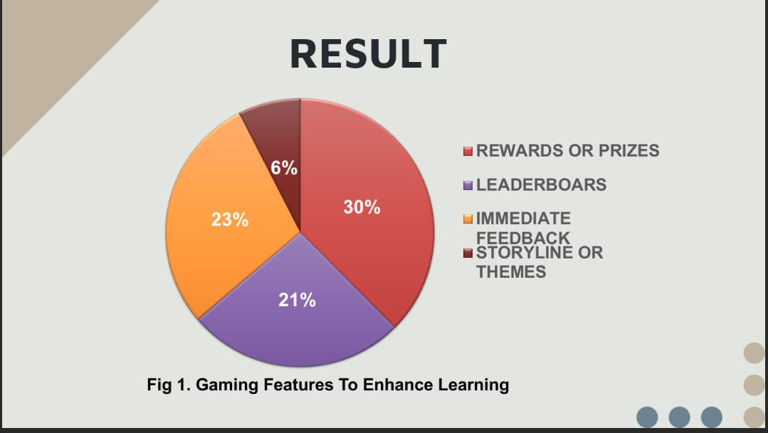

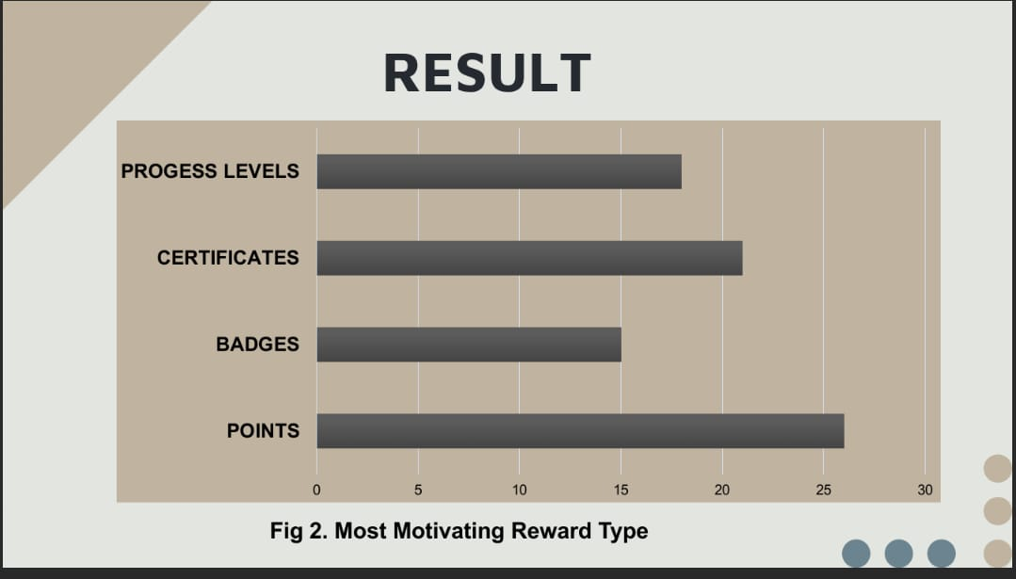

**Conclusion:**

In conclusion, this study highlights the effectiveness of gamification in enhancing student engagement and performance. By integrating game mechanics into the learning process, gamification makes education more enjoyable and improves academic outcomes. The findings emphasize the importance of adopting gamified approaches to foster motivation, critical thinking, and achievement, offering valuable insights for educators and policymakers to enhance contemporary learning environments.